A Comparative Study on an RC Frame Building with Different Types of Bracing for Various Seismic Zones

**Shejal Jain1, Rakesh Grover2**

1ME Student, Department of Civil Engineering, Jabalpur Engineering College, Jabalpur (M.P.)

2AsoociateProfessor,Department of Civil Engineering, Jabalpur Engineering College, Jabalpur (M.P.)

*Corresponding author: SHEJAL JAIN

Department of Civil Engineering,

Gokalpur, Jabalpur, Madhya Pradesh 482011, India

**E-mail address:** shejaljain58[@email.com](mailto:kravi_73@rediffmail.com)

**ABSTRACT:**

Most of the reinforced concrete buildings failed due to earthquake strikes in that region. So it is critical to select an effective lateral load-resisting system. In the RCC frame, the more prominent significance is given to creating a structure secure against lateral load. To stand up to lateral load acting on a building different types of steel and RCC bracing systems are provided. In this study, the seismic analysis of reinforced concrete framed structures with different types of bracing X- bracing, inverted V bracing, and diamond bracing etc. are investigated in the designing software STAAD.Pro Connect Edition. A G+4 RC framed structure is analyzed for various seismic zones using STAAD.Pro Connect Edition software as per IS code 1893:2016 (Part 1). It is found that the X-type of steel bracing systems significantly contributes to the structural stiffness and reduces the maximum inter-storey drift of RC frame structure than other all the bracing systems. It is also concluded that base shear is maximum for X-type of bracing system other than all the bracing systems for the same seismic zones.

**KEYWORDS:** Seismic analysis, Seismic zones, X-bracing, Inverted V-bracing and Diamond bracing, RC frame, STAAD.Pro Connect Edition.

**INTRODUCTION :**

The essential reason of all kinds of basic frameworks utilized within the building type of structures is to exchange gravity loads effectively[9]. The most common loads coming about from the effect of gravity are dead load, live load and snow load. Other than these vertical loads, buildings are too subjected to lateral loads caused by wind, impacting or earthquake. Horizontal loads can develop high stresses, deliver sway movement or cause vibration. Subsequently, it is exceptionally critical for the structure to have sufficient quality against vertical loads along -side satisfactory stiffness to resist lateral forces[7]. Bracing members are organized in so numerous shapes, which carry exclusively tension, then again tension and compression. The bracing is made of crossed diagonals, when it is planned to resist as it were tension. Based on the direction of wind, one diagonal takes all the tension whereas the other diagonal is expected to remain inactive. One of the most common arrangement is the cross bracing. There are other types of bracing systems like V and inverted V sort bracing. Braced frame give resistance to lateral force by their bracing action. The braces recreate force within the related bars and columns, so that all work together as one like truss member[8]. A bracing system improves the seismic performance of the frame by increasing its firmness and capacity.

Brace hysteretic behaviour is additionally very complex; showing unsymmetrical properties in tension and compression, and typically appearing substantial quality deterioration when loaded monotonically in compression or consistently into the inelastic range[2].

Concentric bracings increases the lateral stiffness of the frame hence increases the characteristic frequency and also usually decreases the lateral story drift. However, increase within the stiffness may attract a larger inactivity force due to earthquake[3]. Further, whereas the bracings decrease the bending moments and shear forces in columns and they increase the axial compression within the columns to which they are associated. Eccentric Bracings reduce the lateral stiffness of the system and improve the energy dissipation capacity. The lateral stiffness of the system depends upon the flexural stiffness property of the beams and columns, hence reducing the lateral stiffness of the frame. The vertical component of the bracing forces due to earthquake causes horizontal concentrated load on the beams at the point of connection of the eccentric bracings[1].

The main aim of the present study is to know the effect of bracings on the RC framed structure. How the different types of bracings enhance the overall performance of the building and to identify the suitable bracing system for resisting the seismic load efficiently.

**OBJECTIVE OF THE STUDY :**

There are following objectives of this study:

* The designing and analysis should be done using the codes IS codes 456:2000 and IS 1893:2016 (Part1).
* The modeling should be done in STAAD.Pro Connect Edition software.
* Compare the story drift of RC frame building without bracing and with Diamond, Inverted V, and X bracing systems for the various types of seismic zones.
* Comparison of base shear of RC frame building without bracing and with Diamond, Inverted V, and X bracing systems for the various types of seismic zones.

**METHODOLOGY :**

A G+4 RC frame building will be analyzed in the STAAD.Pro Connect Edition software. Seismic load is assigned with different types of bracings X bracing, Inverted V bracing and diamond bracing for all the seismic zones as per IS 1893:2016 (Part1) code. The building configurations will be given in Table 1.

**Table 1. Building Specification**

|  |  |  |
| --- | --- | --- |
| S No. | Design parameters | Design data |
| 1 | Building cross-section | 18m x 18m |
| 2 | No. of bays | 6 |
| 3 | number of stories | 5 |
| 4 | floor height | 3m |
| 5 | Beam cross section | 300mmx 300mm |
| 6 | column cross section | 450mmx450mm |
| 7 | slab thickness | 125mm |
| 8 | Steel Bracing | ISA 100X100X12 |
| 9 | concrete | M25 |
| 10 | steel | Fe415 |
| 11 | specific weight of RCC | 25KN/M2 |
| 12 | Earthquake directions | X,Z,-X and -Z |
| 13 | seismic zones | II,III,IV and V |
| 14 | soil type | Medium soil |
| 15 | Earthquake loads | As per IS 1893:2016 (Part1) |
| 16 | Damping ratio | 5% |
| 17 | Response reduction factor | 5 |
| 18 | Importance Factor | 1 |

**MODELLING :**

Design modules within STAAD.Pro Connect Edition automates the process of designing structural elements according to the selected design codes. It provides a comprehensive suite of tools for the modeling, analysis, design, and documentation of various types of structures. A G+4 RC framed building will be modeled using the STAAD.Pro Connect Edition software as per Indian standard codes IS 1893:2016 (Part1) and IS 456:2000. The plan of the RC frame structure is given in Figures 1 and 2. Here, Figure

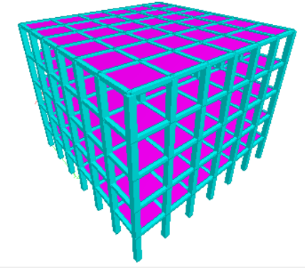

3 shows the 3D models of RC frame building without bracing. Figures 4 , 5 and 6 shows the 3D models of RC frame building with X bracing, inverted V- bracing and Diamond bracing respectively.

**Fig. 2. Top view of RC frame structure**

**Fig 1. Side view of RC frame structure**

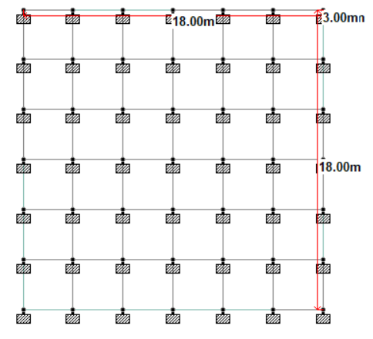

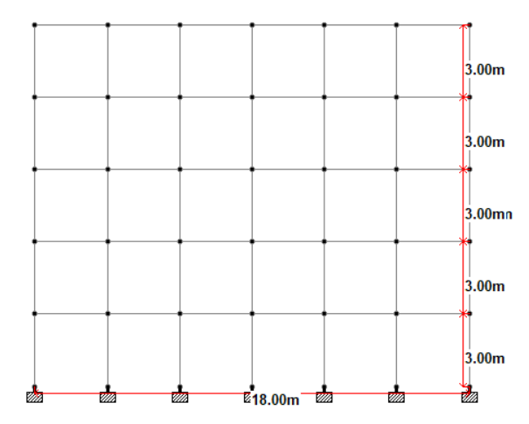

**Fig. 5. 3D model of RC frame building with inverted V-bracing.**

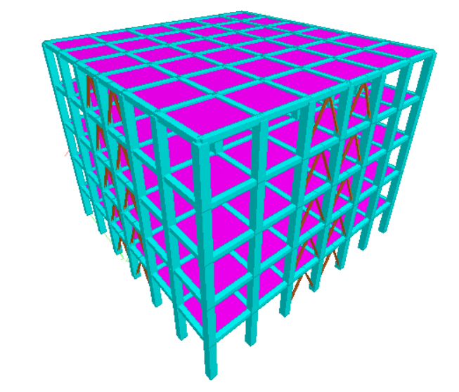

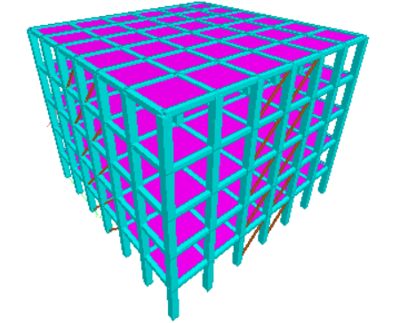

**Fig. 6. 3D model of RC frame building with Diamond bracing.**

**RESULT AND DISCUSSION :**

**Fig. 8. Outcomes of RC frame building with Diamond bracing.**

**Fig. 7. Outcomes of RC frame building without bracing.**

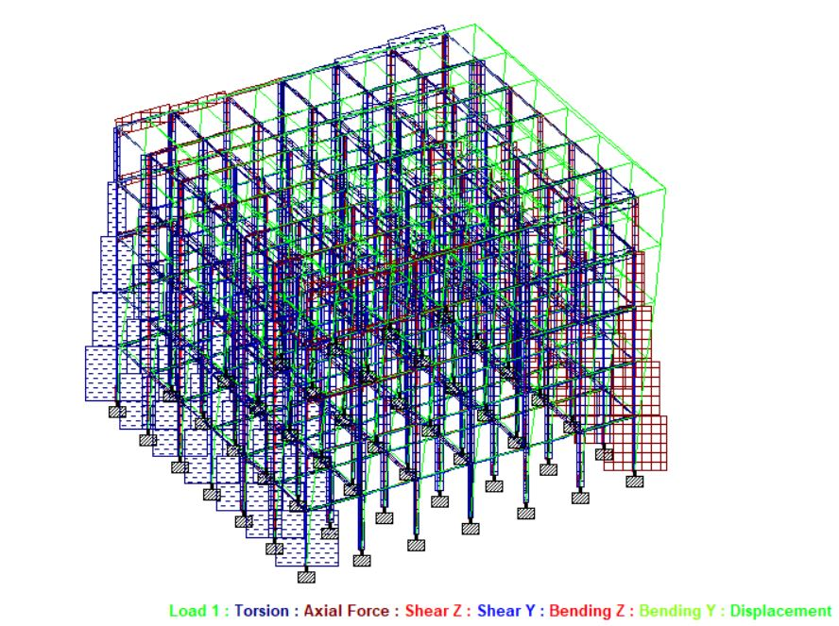

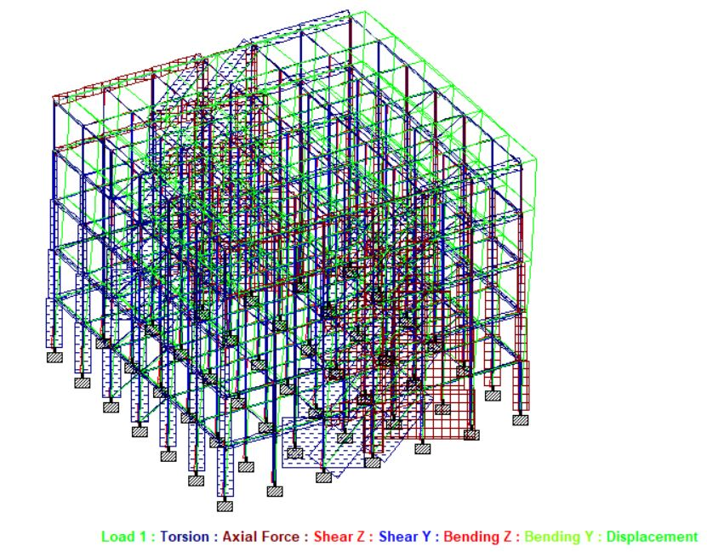

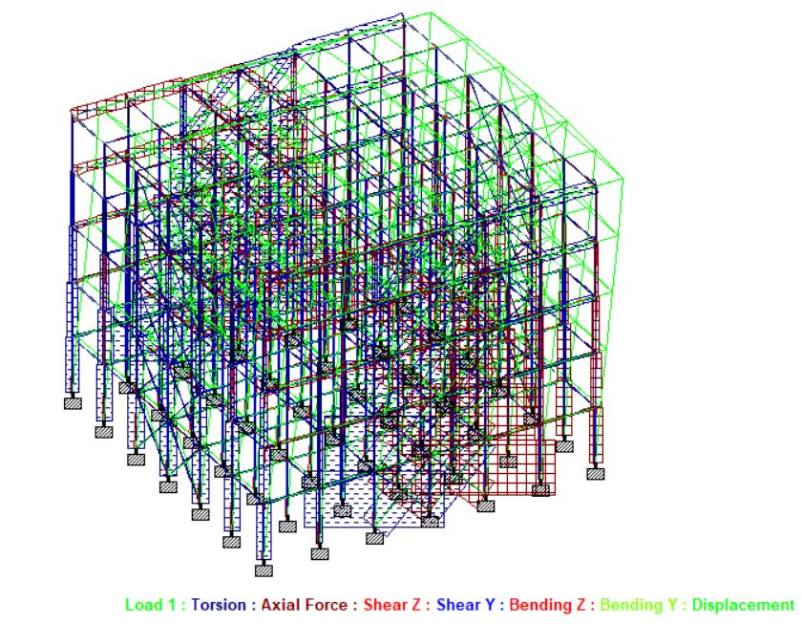

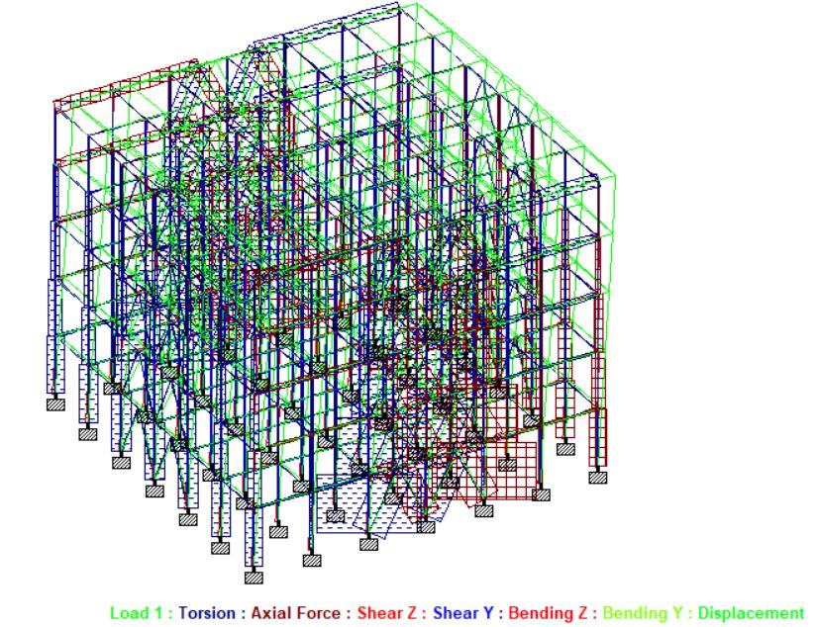

**Fig. 10. Outcomes of RC frame building with X-bracing.**

**Fig. 9. Outcomes of RC frame building with Inverted V-bracing.**

The above figures shows the torsion, axial force, Shear force, bending moment and displacement diagrams of the RC frame building with without bracing, diamond bracing, inverted V bracing and X bracing respectively.

**Fig 11. Comparison of Storey drift of RC frame building with different types of bracing for Zone 2.**

**Fig 12. Comparison of Storey drift of RC frame building with different types of bracing for Zone 3.**

**Fig 14. Comparison of Storey drift of RC frame building with different types of bracing for Zone 5.**

**Fig 13. Comparison of Storey drift of RC frame building with different types of bracing for Zone 4**.

Figures 11, 12, 13 and 14 represents the comparison of story drifts of RC frame building with without bracing, diamond bracing, inverted V bracing and X bracing for the various types of seismic zones respectively.

**Fig 16. Comparison of Base shear of RC frame building with different types of bracing for Zone 3.**

**Fig 15. Comparison of Base shear of RC frame building with different types of bracing for Zone 2.**

**Fig 18. Comparison of Base shear of RC frame building with different types of bracing for Zone 5.**

**Fig 17. Comparison of Base shear of RC frame building with different types of bracing for Zone 4.**

Figures 15, 16, 17 and 18 represents the comparison of Base shear of RC frame building with without bracing, diamond bracing, Inverted V bracing and X bracing for the various types of seismic zones respectively.

**CONCLUSIONS :**

Comparison is done based on relative displacement, maximum shear force, maximum axial force, maximum bending moment, maximum tensile stress, the maximum compressive stress in different seismic zones. In all models, the displacement values are less for lower zones and it goes on increase for higher zones. The key factors of the study are comes out.

* The storey drift of the RC frame building is decreasing more for X type of bracing other than all the bracing systems after comparing in the same seismic zones.
* The base shear of the RC frame building is increasing more for X type of bracing other than all bracing systems after comparing in the same seismic zones.
* It seems that the maximum shear forces and maximum bending moments are increasing when we go from seismic zone II to Zone V.
* It also concludes that wherever the height of the structure is increasing the max shear force, max bending moment, storey drift, and base shear of the building are increased.

**CONFLICT OF INTEREST****:**

The authors have no conflicts of interest regarding this investigation**.**

**ACKNOWLEDGMENTS:**

The authors would like to thank Dr. Rakesh Grover for their kind support during the research work and all other software and IS code studies.

**REFERENCES :**

[1] Biradar, U. R., & Mangalgi, S. (2014). Seismic response of reinforced concrete structure by using different bracing systems. *Int J Res Eng Technol*, *3*(9), 422-426.

[2] Brahmanand and Pandey R. K. 2021. Seismic Analysis of the RC Structure with Different Bracing System: A Review. International Research Journal of Engineering and Technology, *8*(06).

[3] Chavan, K. R., & Jadhav, H. S. (2014). Seismic response of RC building with different arrangement of steel bracing system. *International Journal of Engineering Research and Applications*, *4*(7), 218-222.

[4] Duggal S K, Earthquake Resistance Design of Structure.

[5] IS: 456-2000 (Indian Standard Plain Reinforced Concrete Code of Practice) – Fourth Revision

[6] IS: 1893-2002 (part-1) criteria for earthquake resistant design of structures fifth revision, Bureau of Indian Standards, New Delhi.

[7] Mohammed, N., & Nazrul, I. (2013). Behaviour of Multistorey RCC Structure with Different Type of Bracing System (A Software Approach). *International journal of innovative research in science, engineering and technology*, *2*(12).

[8] SOMASE A. N. et al 2021. GAIKWAD Seismic Analysis of RCC Structure with Various Types of Bracing System Using ETABS for Different Seismic Zone. *INTERNATIONAL JOURNAL*, *9*(7).

[9] Tanaji, B. A., & Shaikh, A. N. (2016). Analysis of reinforced concrete building with different arrangement of concrete and steel bracing system. *INTERNATIONAL JOURNAL*, *2*(4).